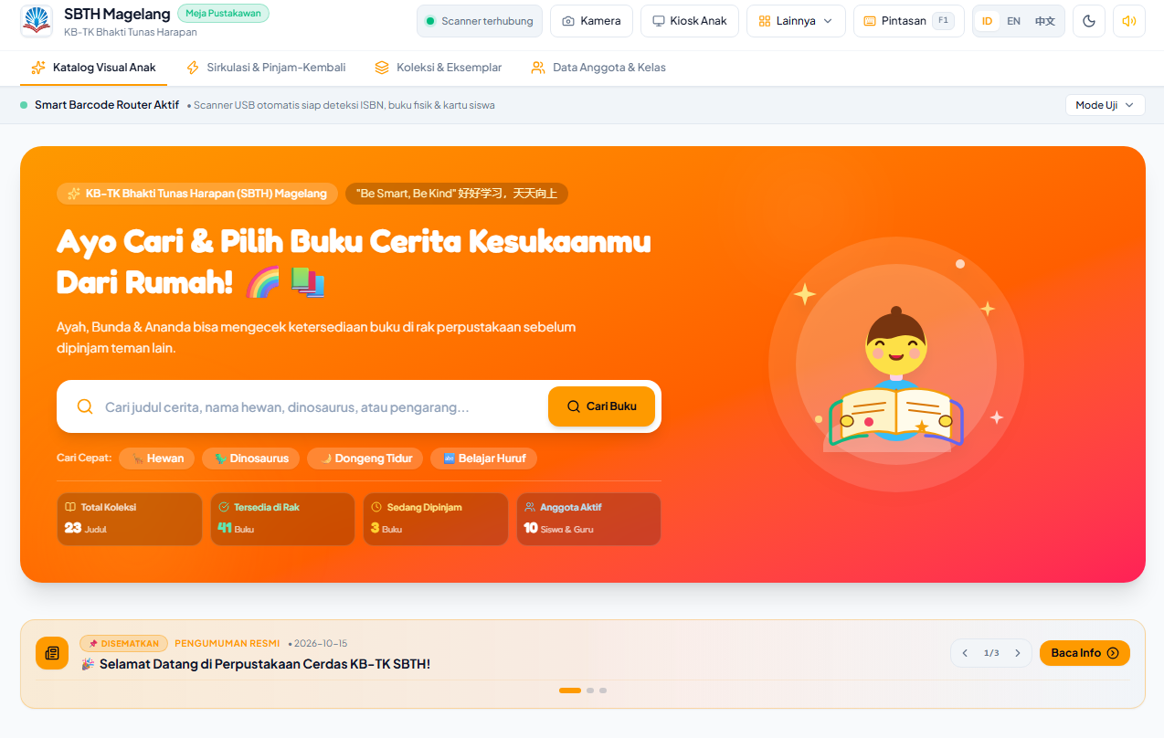
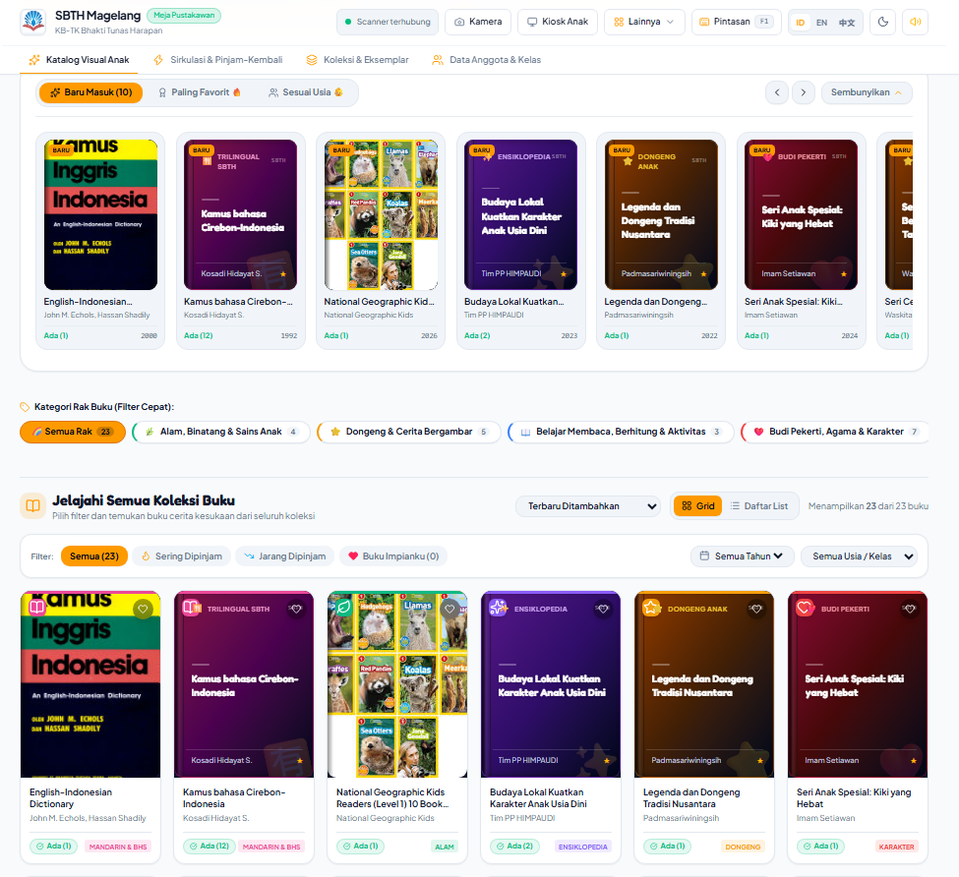
HOME
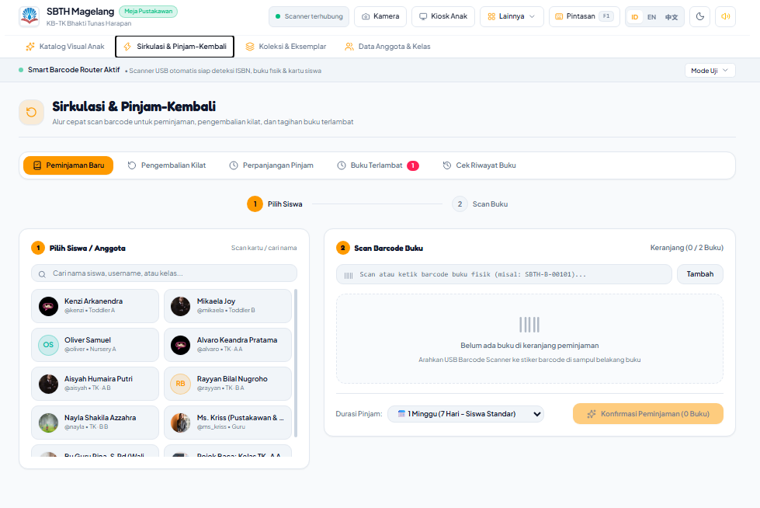
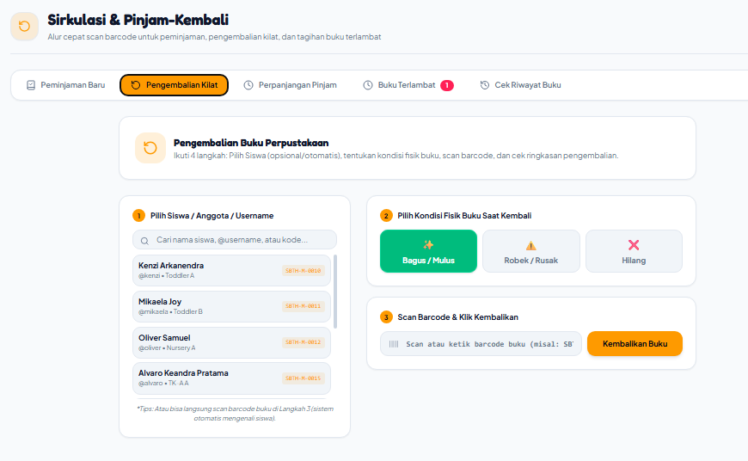
SIRKULASI
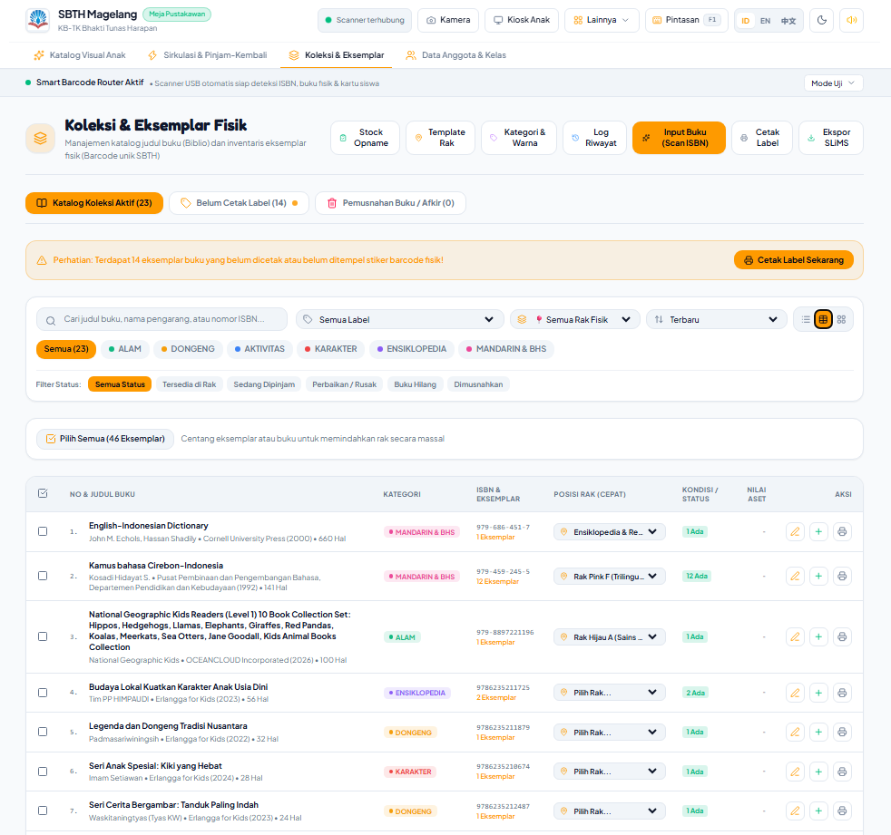
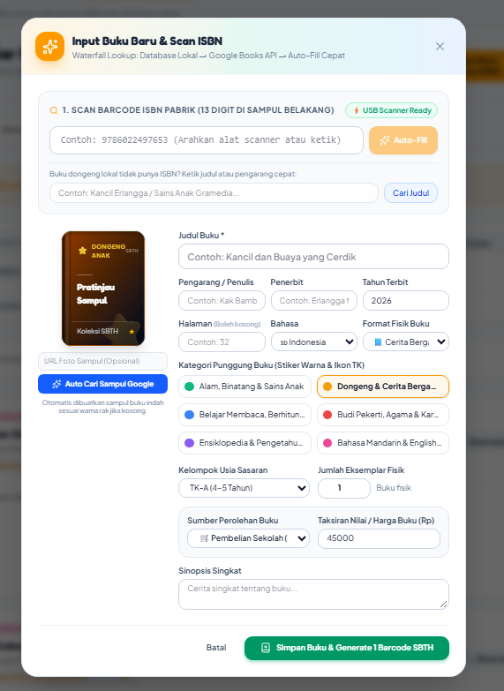
BIBLIOGRAPHY / KOLEKSI
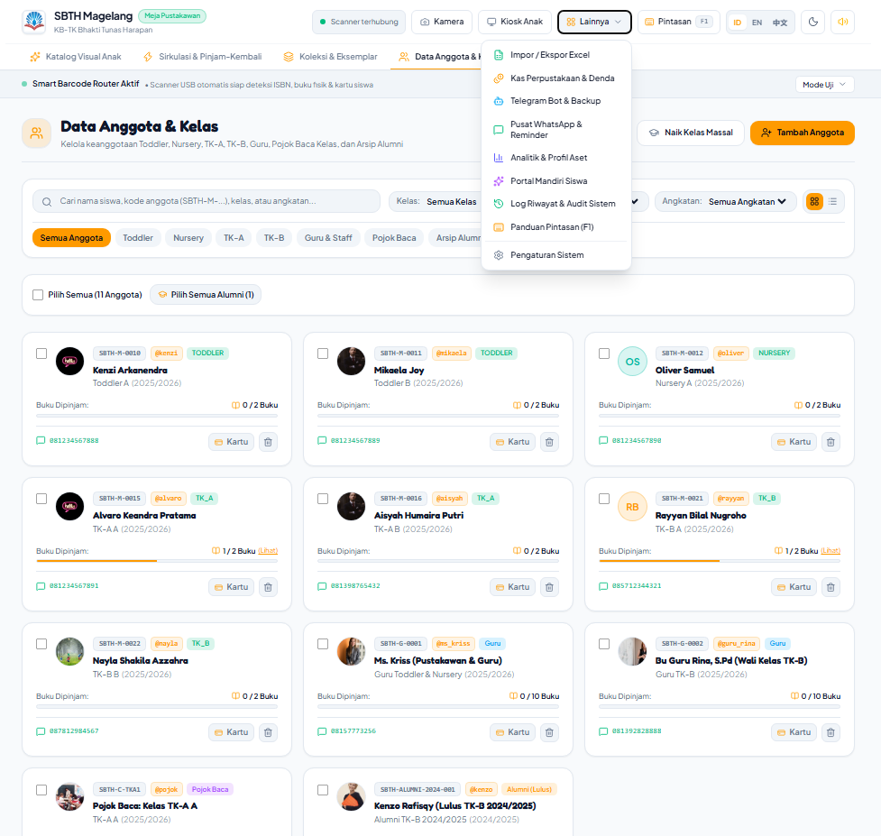
Video DEMO : https://youtu.be/cU9K9IK8Zg8
Link Download, Panduan, Penjelasan :
https://github.com/prasetyohk/Sistem-Perpustakaan-SBTH
Link Download Google Drive : https://shorturl.at/qU6lI
atau
https://drive.google.com/file/d/1zjv4mFNl6qDvdFy9H2eT-WM8mE2_OWL2/view?usp=drive_link

